Personal statement

A highly motivated recent graduate with an honors degree in computer science, a portfolio of A-grade applications,

and contributor towards several open-source projects. Prior to my degree, I have a strong record of accomplishment in the luxury architectural illustration sector, providing exemplary levels of service to leading organizations such as RMJM, St Paul's Cathedral and Cambridge University. This experience has enabled me to develop not only specific media industry experience, but also a valuable and transferable skill set in this fast-paced sector.

Since obtaining my degree, I have worked on several successful projects such as unitool.info and my visualization studio. Utilising excellent communication skills, I have developed and maintained successful working relationships with internal and external colleagues.

**Junior java/php/c++/web developer**

**T:01902 422 831** **M:07816 426 797**

**Address: 44 Leicester Street, Wolverhampton**

[**E:matthew@mlfvs.info**](mailto:matthew@mlfvs.info)

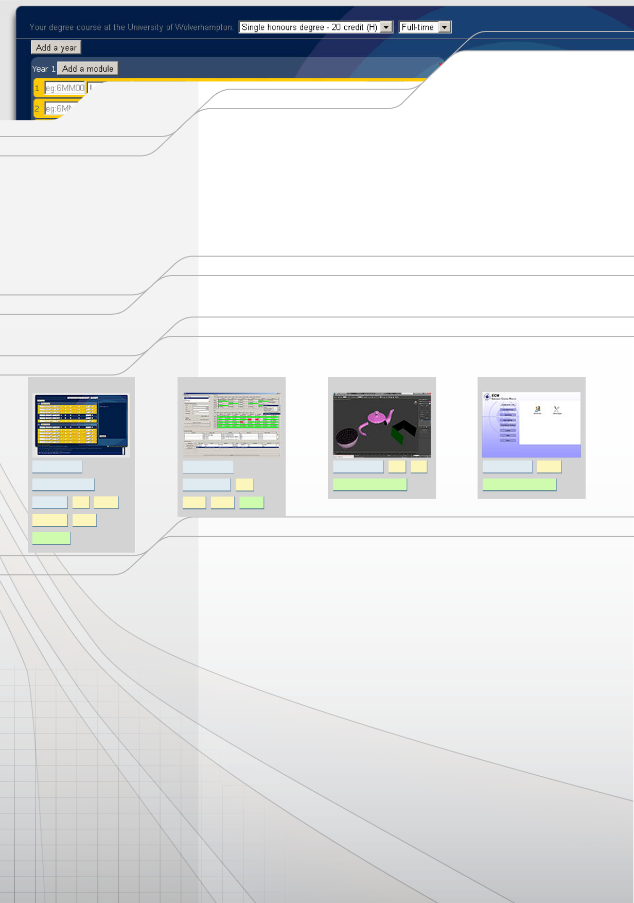

Presently looking to secure a position in a software/web development organization, where I can bring immediate and strategic value and develop my skill set further.

Education

2009 - 2011 Computer Science (BSc)

University of Wolverhampton (UK)

University of the Arts, London (UK) Foras Aiseanna Saothair Tralee (IRL)

2:2

Merit+ City&Guilds

2004 - 2006

2000 - 2001

Portfolio

[Unitool.info](http://mlfvs.info/resume)

Computer games production (FDa)

2D/3D cad

download portfolio software from mlfvs.info/resume

[S4S](http://mlfvs.info/resume)

[Halver 3ds max](http://mlfvs.info/resume)

[EC Monitor](http://mlfvs.info/resume)

[php developer](http://mlfvs.info/resume)

[java developer](http://mlfvs.info/resume)

[c++ developer c++](http://mlfvs.info/resume)

[uml](http://mlfvs.info/resume)

[.net developer vb.net](http://mlfvs.info/resume)

[web designer](http://mlfvs.info/resume)

[scrum master](http://mlfvs.info/resume)

[java](http://mlfvs.info/resume)

[extreme programming](http://mlfvs.info/resume)

[RAD methodologies](http://mlfvs.info/resume)

[sysadmin php](http://mlfvs.info/resume)

[drupal](http://mlfvs.info/resume)

[swing mysql](http://mlfvs.info/resume)

[scrum](http://mlfvs.info/resume)

[javascript jquery](http://mlfvs.info/resume)

[test-driven](http://mlfvs.info/resume)

Employment History

2010 - 2012

Independent developer

unitool.info

Wolverhampton

-Sole developer on a web application that converts University of Wolverhampton's 200+ degree regulations into a simple ui for students to figure out their progression-trajectory.

-5000 monthly users.

-Concept, design, development, hosting and security all managed in-house.

2010 - 2012

Architectural visualization artist

mlf visual studio

Wolverhampton

-Owner/manager of a small cg studio making cg images and animations for architectural projects.

-Highlights include working on St Paul's Cathedral and scripting a geometry conversion utility for issuing sketchup models to clients.

2007 - 2009

Lead architectural visualization artist

rmjm

Cambridge

-lead visualizer making award-winning images and animations for rmjm's uk projects including Universities of Hertforshire, Buckinghamshire, Bedfordshire, Coventry and Leicester DeMontfort.

-Awards include rmjm "best visualization ever", and bdonline "Image of the week".

-Coordinated teams of up to four specialists.

-Developed an automated render farm of 200+ PCs using sysinternals tools, batch files and wakeonlan.

2004 - 2007

Architectural visualization artist

freelance

London

-Responsible for making images of residential and leisure architectural projects across London, including

Hemel Hempstead reconstruction following the explosion in 2005.

2005 - 2006

Software tester

razorback

Croydon

-Responsible for examining new builds of World of Warcraft on Nokia Ngage to verify fixed bug status.

-Credited with fixing bugs and appeared in the credits roll - next to William Shatner

OTHER ACHIEVEMENTS: 2004 Paris Marathon - Ring of Kerry Cyclist 2004 - Nvidia Unreal Contest entrant 2004 - Student Course Rep 2004-06 - Four peaks (Ben Nevis,

Snowdon, Carrauntoohil, Scafell) 2005 - Feltham Faith Mentor Certificate 2007 - Building Design Image of the Week 2009 - Student Course Rep 2009-11 -